UNLOCKING INSIGHTS INTO THE GLOBAL AIR TRANSPORTATION NETWORK

1. Introduction

1.1 Overview:

The air transportation network is a complex network which has the properties of small world networks and scale free networks the degree distribution of the nodes displays a heavy tailed distribution. The hubs of the network have large connectivity and long distance connections. The importance of air transport lies in its Ability as an economic engine to generate and support jobs strengthening trade and connectivity between people and countries promote tourism and connect remote communities.

1.2 Purpose:

Air transport allows people from different countries to cross international boundaries and travel other countries for personal, business, medical, and tourism purposes.

2. Problem definition and design thinking

Empathy map:

Brain storm:



Result:

Dashboard:









Story

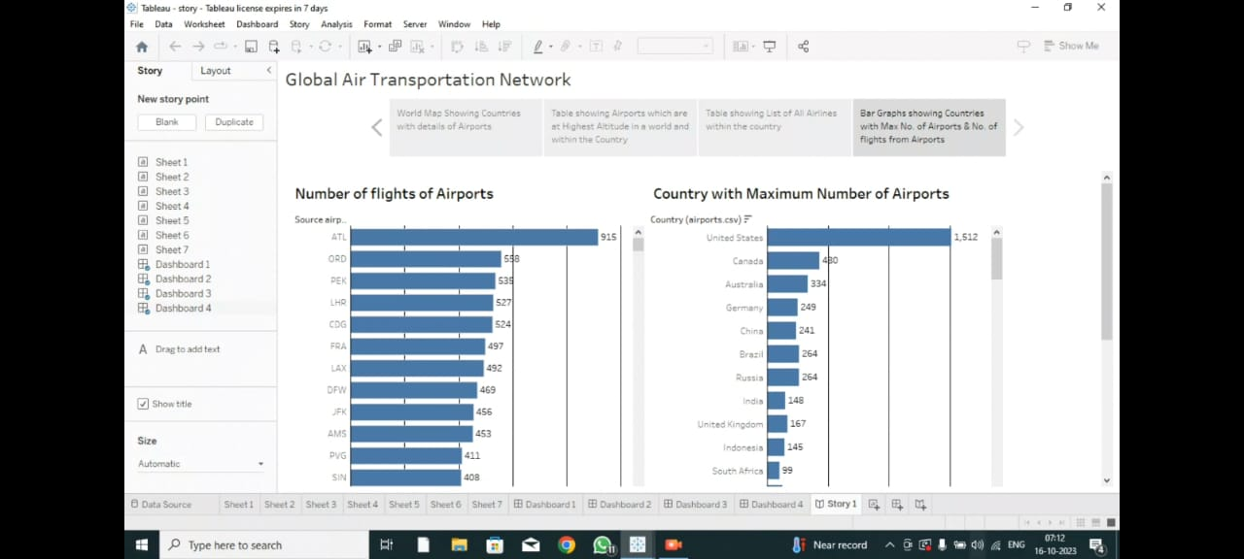

Advantages of Air Transport

1. High Speed

Air is the type of freight capable of traveling long distances in short periods of time. This makes this model an optimum choice if the client has an urgent need to ship a product or if their freight demands special standards of protection or acclimation. It is the quickest transport mode and is therefore ideal for long-distance transport of goods. It takes less time.

2. Fast Service

Air transportation offers convenient, reliable and fast services of transport. It is considered the cheapest way to ship peregrinated goods. It offers a standard, convenient, reliable and fast service.

3. Send almost everywhere your freight

In regions that are not readily accessible to other modes of transport, air transport is considered to be the only means of transport. Open to all regions, irrespective of land interference. A vast network of airlines covering nearly the whole globe is available for many airlines. This ensures that the package can be sent almost anywhere.

4. High Standard of Security

Shipping by air has a high degree of security since airport safety restrictions on cargo are strictly enforced. Tightly controlled airport controls also minimize cargo theft and loss.

5. Natural Route

An aircraft can fly to any location without seeing any natural obstacles or barriers. Since customs formalities are easily compiled. It eliminates the need for more time to seek clearance. Air travel is used for relief operations during earthquakes, floods, accidents, and famines.

6. There is less need for heavy packaging

Air exports, in general, entail less hard packaging than ocean shipments. This ensures you save both time and money by not having to provide extra packaging services.

Disadvantages of Air Transport

Climate conditions that are adverse: Extreme weather will cause planes to be grounded and airports to close, halting shipments for several days and rendering the service ineffective.

1. Risky

Air travel is the riskiest mode of transport, since there can be considerable losses to goods, customer and crews as a result of a minor crash. Compared to other means of travel, the risks of collisions are higher.

2. Cost

Air travel is considered to be the most expensive means of transportation. The cost of maintaining aircraft is higher and the costs for the building of aerodromes is much higher. That’s why air travel is so expensive that it gets beyond ordinary people’s grasp.

3. Some Product Limitation

There is a whole variety of materials not suitable for such products, from explosives, gases, batteries, fired solids and liquids, which cannot be shipped by air to name but a few.

4. Capacity for Small Carriage

The aircraft have no room and therefore are not ideal for carriage of voluminous and cheaper materials. As is seen for rails, the load volume cannot be raised.

5. Enormous investment

Air travel calls for enormous spending in aerodrome building and servicing. It also calls for professional, qualified and qualified.

Application:

Air transport is currently used in almost all industrial sectors and distribution chains. Most companies use air transport to market goods and products internationally or to deliver samples and documents related to foreign trade operations.

Conclusion:

Conclusion for our project that the air transport industry is not only a vital engine of global socio-economic growth but is also of vital importance as a catalyst for economic development in most countries and for many regions within each country staff that need a significant investment.

Future scope:

The industry has a number of domestic and international airlines, as well as a large network of airports. The future of the aviation industry in India is likely to see continued growth and expansion, driven by factors such as a growing middle class, increased tourism, and government policies supporting the industry.

Appendix:

Dashboard:

<https://public.tableau.com/views/dashboard1_16974442595560/Dashboard1?:language=en-US&:display_count=n&:origin=viz_share_link>

<https://public.tableau.com/views/dashboard2_16974443641910/Dashboard2?:language=en-US&:display_count=n&:origin=viz_share_link>

<https://public.tableau.com/views/dashboard3_16974444800340/Dashboard3?:language=en-US&:display_count=n&:origin=viz_share_link>

<https://public.tableau.com/views/dashboard4_16974446316650/Dashboard4?:language=en-US&:display_count=n&:origin=viz_share_link>

Story

<https://public.tableau.com/views/story1_16974447238990/Story1?:language=en-US&:display_count=n&:origin=viz_share_link>